Module 4:
- Explain DGIM algorithm for counting ones in a stream with example.
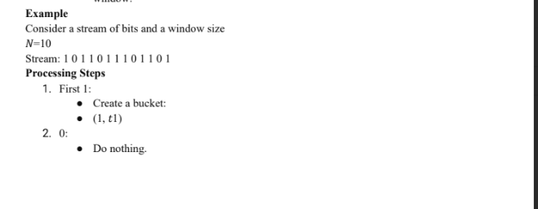
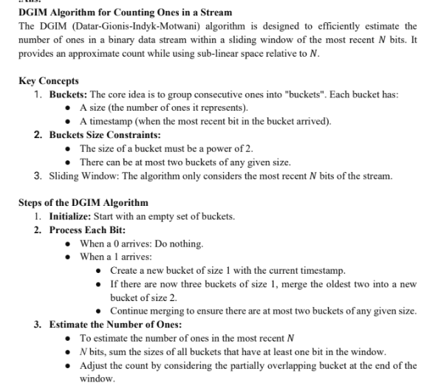

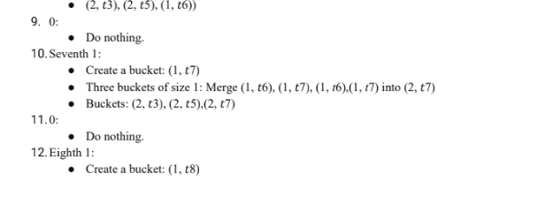
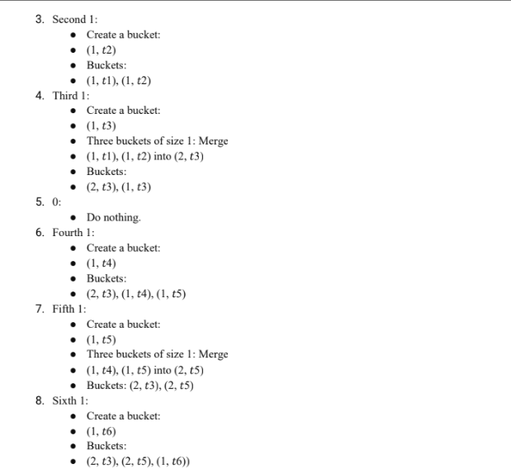

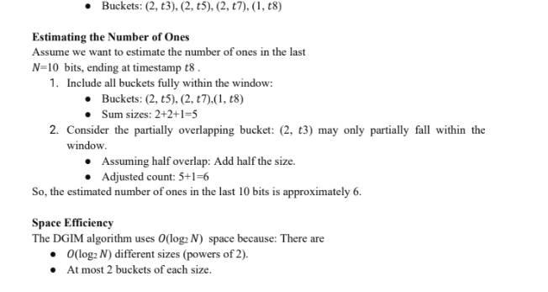
2. Define Bloom Filter? How bloom filter is useful for big data analytics.

4.Define the Stream Data Model and explain its significance in real-time data processing.
5. Explain the primary types of queries identified as typical over data streams.

